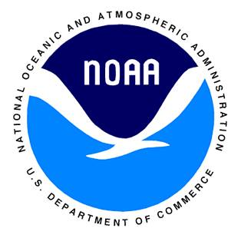 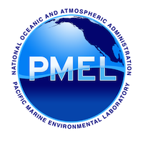**PLEASE HANDLE WITH CARE, DELICATE SCIENTIFIC INSTRUMENT INSIDE,**

**NO HAZ MAT**

POC:

LTJG Sarah Donohoe

7600 Sand Point Way NE

Seattle, WA 98115

email: [sarah.s.donohoe@noaa.gov](mailto:sarah.s.donohoe@noaa.gov), work: 206-526-6746, cell: 907-209-6978